Important
New Court Procedure
Kane County Civil and Family Courts
E-File Proposed Orders
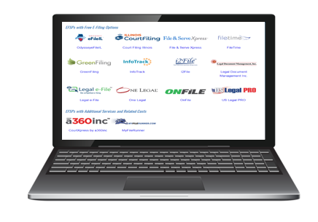
using the State Mandated E-Filing application.
Civil April 5th and Family April 12th

What this means for you....
- Submit orders through your chosen provider.
- Select E-File PROPOSED ORDER filing code to route the order.
- In order to receive file stamped copies of the order include Service Contact/Case Contact in your filing.
QR For
Detailed
Information
- General Order to come.

